Bio – Eva Meekins, DNP, MHN, MN, RN
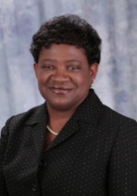
Eva Meekins is a Nurse Educator with the Centers for Disease Control and Prevention, National Center for Immunization and Respiratory Diseases, Health Education and Communication Branch.
Eva holds a doctorate in nursing practice, educational leadership, and curriculum design. She also holds two master’s degrees- one in healthcare administration and a second master’s in nursing with an adult clinical nurse specialist emphasis. She has extensive professional practice experience in critical care, adult health, and various public health affiliations. Before joining the CDC, Dr. Meekins was a hospital nurse administrator, university professor, and director of nursing education for nearly 20 years.

